

Emac denug SOP

Revision History

Document Version | Date | Author | Comment
V 0.0.1 | 2012/03/04 | Namodtum.lu | Create

Content
1. OSI model 4
2. Smartbit performance issue 4

- OSI model
The Open Systems Interconnection (OSI) model (ISO/IEC 7498-1) is a product of the Open Systems Interconnection effort at the International Organization for Standardization. It is a prescription of characterizing and standardizing the functions of a communications system in terms of abstraction layers. Similar communication functions are grouped into logical layers. A layer serves the layer above it and is served by the layer below it.
For example, a layer that provides error-free communications across a network provides the path needed by applications above it, while it calls the next lower layer to send and receive packets that make up the contents of that path. Two instances at one layer are connected by a horizontal connection on that layer.
Mstar emac driver belongs to data link layer.
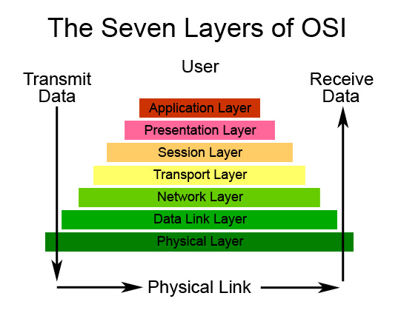
Fig. 1
- Smartbit performance issue
  - Use “cat/proc/net/snmp” to monitor packet propagate among network and transport layers as Fig.1
    - The InType0 in IcmpMsg shows that kernel receive 2 ICMP packets from network layer to transport layer
    - The OutType8 in IcmpMsg shows that kernel sent 2 ICMP packets from transport layer to network layer
    - The OutRequests in Ip shows that kernel sent 2 packets from network layer to data link layer
    - The OutDiscards in Ip shows that kernel drop no packets in network layer
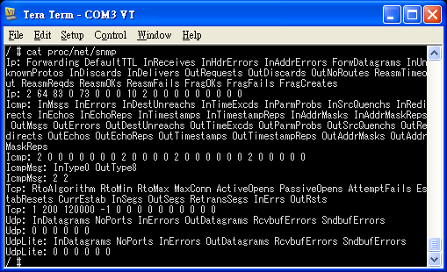
Fig. 2

  - Use “ifconfig” to monitor packets in and out Mstar emac HW IP
    - In this case, mstar emac receive 45 packets from physical layer, and sent 3 packets out.
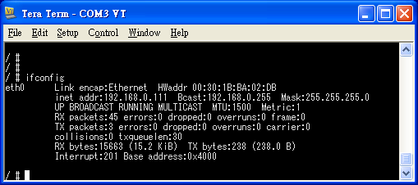
Fig. 3

